Client Server System

* Visual studio
  + Create a project (console app)
  + Object browser = > can see all built-in object in Visual Studio
  + Can see visual class diagrams

Composite Formatting

* { index[,alignment][:formatString]}
* 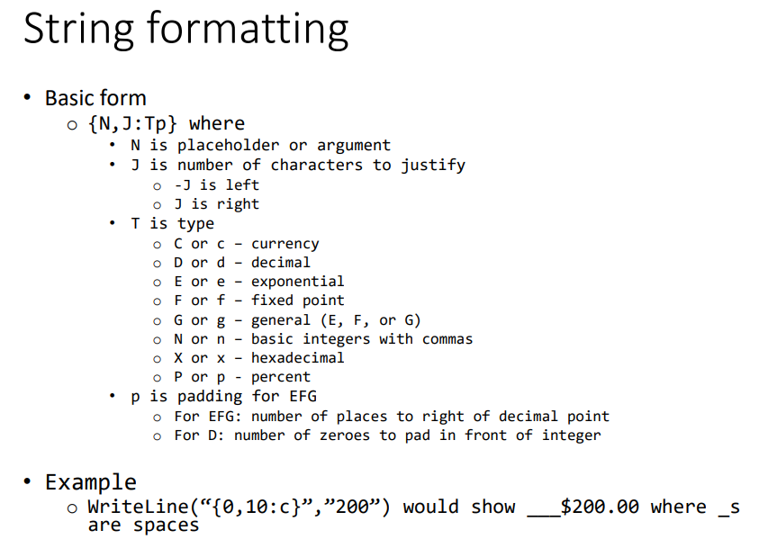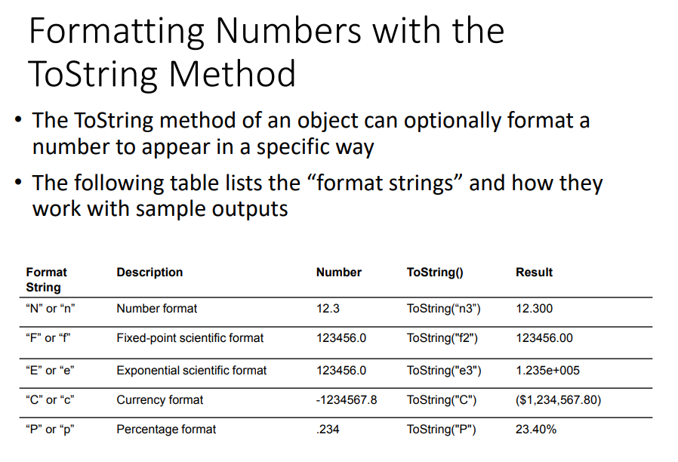
* Reference

<https://docs.microsoft.com/en-us/dotnet/standard/base-types/composite-formatting>